**National University of Computer &**

**Emerging Sciences Karachi Campus**



COMPUTER SHOP MANAGEMENT SYSTEM

Project Report

DATABASE SYSTEMS

BCY – 5A

20K-0329 ARHAM AFZAL

20K-1050 YAHYA NAVED

**DESCRIPTION:**

This project targets local computer shop owners who have a clustered shop system usually found in the saddar market. This project aims to help them have an organized and managed system which would help them manage their customers, cash inflow, outflow, the remaining stock of all the components available.

**ENTITIES:**

* USERS: Stores the data for the shop owner and the workers of the shop who will use this software.
* CLIENTS: The buyers who will place orders for the products, to the users and their data.
* ORDERS: The orders placed by clients for a specific product and its data.
* PRODUCTS: The item which is to be sold on the shop and its data.
* CATEGORIES: The classification of the product and its data.
* SUB CATEGORIES: The sub classification of the product and its data.
* BRANDS: The brand to which the particular product belongs along with its data.

**CONCEPTS USED:**

* Built in SQL functions used for calculation of sums.
* Checks are used to validate the entries.
* PL SQL is used for the updation of quantity.
* Triggers are used to notify insertion of order.
* Transactions (Savepoint & Rollback) used to act as a cart.

**NORMALIZATION PROCESS:**

**1 & 2 NF:**

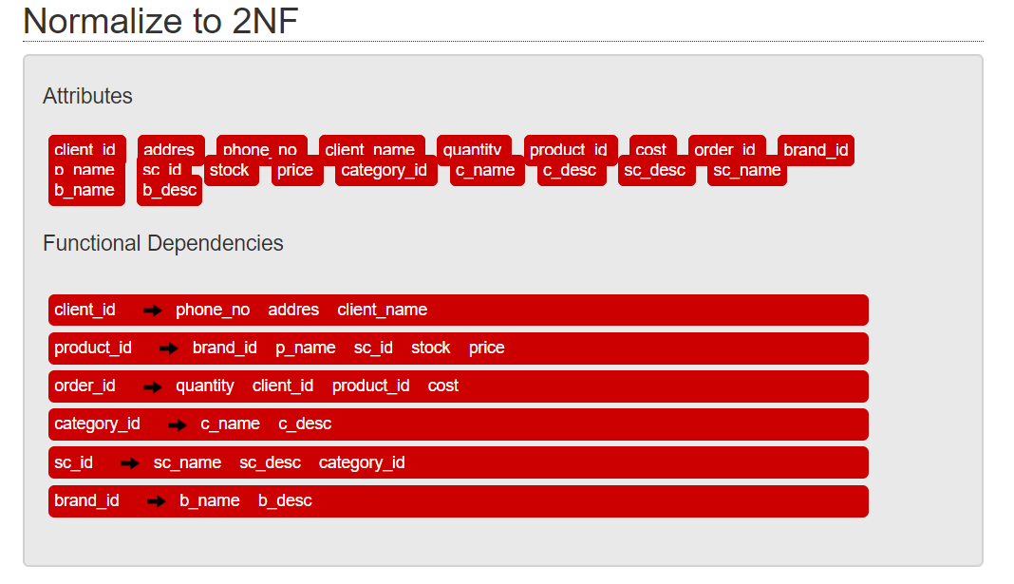

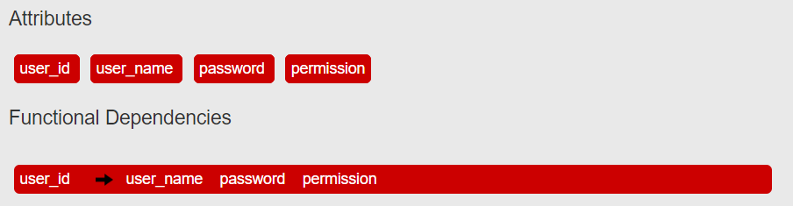

**3 NF & BCNF:**



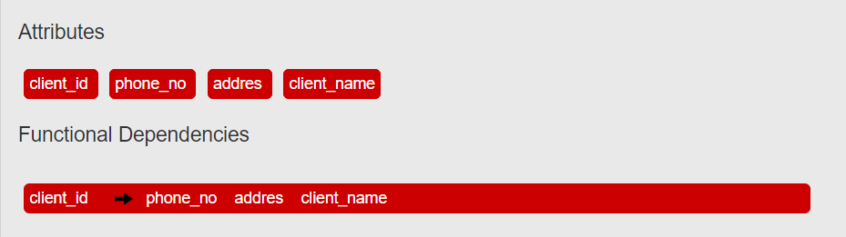

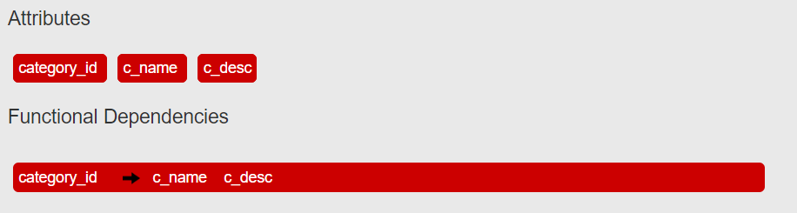

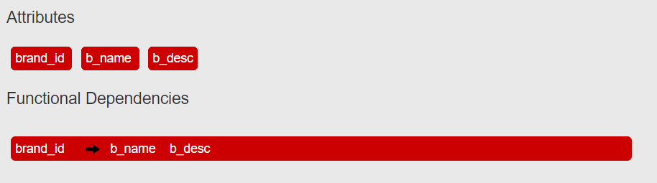

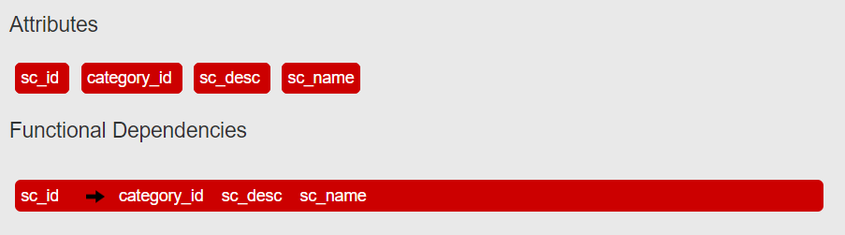

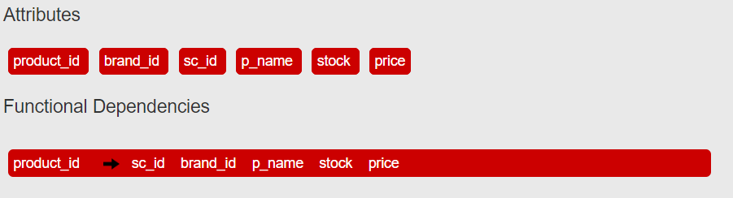

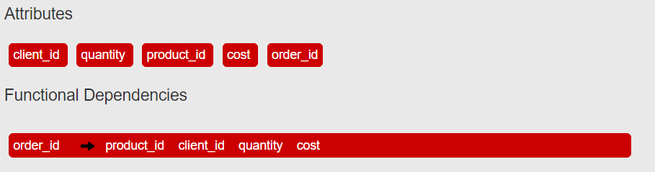

**ER DIAGRAM**